Synopsis

Web Development On Web

Project Domain : Software as a service (SaaS)

Project Sponsorer : Persistent Systems Ltd.

Industrial Guide : Mr. Pravin Kalel

Group Id - 10

Project Group Members:

Milind H Gokhale - 4122
Amit S Gosavi - 4124
Aarti S Mavlingkar - 4143
Manasi A Sahasrabudhe - 4155

Introduction
Software as a service is a model of software deployment where an application is hosted as a service provided to customers across the Internet. By eliminating the need to install and run the application on the customer's own computer, SaaS alleviates the customer's burden of software maintenance, ongoing operation, and support. It reduces up-front expense of software purchases through on-demand pricing for the required services. Hardware cost is reduced. Multitenancy - single instance of the software runs on a software-as-a-service (SaaS) vendor's servers, serving multiple client organizations (tenants).

Key characteristics of S/W delivered by SaaS
- Network-based access to, and management of, commercially available software.
- Activities that are managed from central locations rather than at each customer's site, enabling customers to access applications remotely via the Web.

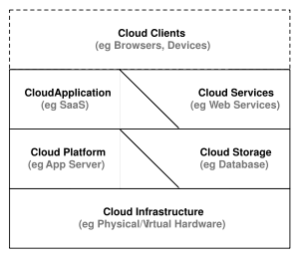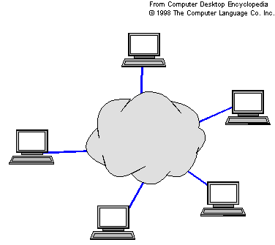

Situation that needs to be addressed
We use Macromedia Dreamweaver or adobe golive for making web pages.
But it requires installation of these software’s on the machines.

Aim of the project
- To solve the stated situation, we can create a web development tool which we have termed as weby web. It will help in creating web pages online on fly. Thus space and resources of the host are not required.

- Weby web is an integrated, SaaS-based platform for building, (planning, publishing) websites. Weby web has a rich environment for building sites that is powerful and flexible, yet simple to use, as everything is drag-and-drop.

- The weby web dashboard provides an area where you can make simple changes to website content. It facilitates user to develop ultra rich web applications using silverlight.

Characteristics of silverlight

- Microsoft Silverlight is a programmable web browser plug-in that enables features such as animation, vector graphics and audio-video playback that characterize rich internet applications.
- It is compatible with multiple web browser products used on Microsoft Windows and Mac OS X operating systems.

Key Features and scope of the project

- WYSIWYG Presto-based editor.

- The coding details are hidden (optional), making it possible for non-coders to
create web pages and sites.

- Weby web allows users to preview websites in many browsers.

Assumptions
SaaS is based upon the assumption that the services provided are commonplace and well defined, hence economies of scale and balancing of supply and demand becomes possible. This assumption holds true for those areas of IT that are ubiquitous, a cost of doing business and commodity-like. SaaS is therefore not suitable for innovative or highly specialized niche systems, though SaaS may be used to provide one or more components in such systems.
Software requirements
Silverlight 1.0 SDK, MS visual studio 2008, MS Expression blend, .NET Framework 3.0 or higher, Web browser, Microsoft windows XP with service pack 2 or Vista.

Minimum System requirements
- Intel® Pentium® or AMD processor, 1 GHz with MMX or equivalent
- 512 MB of RAM
- 350 MB available hard disk space
- Graphics processor that is DirectX® 9-capable
- 1024 x 768 monitor resolution with 24-bit color
Scripting languages
- VBscript, JavaScript.

